**QR Code generator**

High Level Design(HLD)

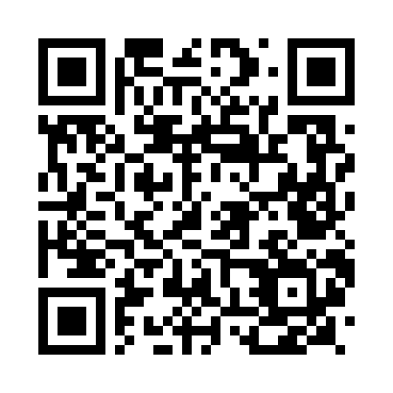

Scan this to view our project

Revision Number: 1.0

Last date of revision-19/12/2021

Contents

Abstract………………………………………………………………………3

1 Introduction……………………………………………………………..4

* 1. Why this High-Level Design Document…………4
  2. Scope……………………………………………………………4
  3. Definitions……………………………………………………5

1. General Description ………………………………………………5
   1. Problem Statement………………………………………5
   2. Proposed Solution………………………………………..5
   3. Further Improvements………………………………….6
   4. Technical Requierments………………………………..6
   5. Data Requirements………………………………………..6
2. Tools Used………………………………………………………………7
3. Initial Step-by-step Description……………………………….8
4. Conclusion………………………………………………………………9

**Abstract**

ABSTRACT QR CODE (Quick Response Code) A QR (quick response) code is a**two-dimensional barcode readable by QR scanners**, smart mobile phones with a camera. QR codes can be used to link to any URL. They can also be used to automatically add information into a user's smartphone such as a calendar event, map or personal contact information.

1. **Introduction**
   1. **Why this High-Level Design Document***?*

*The purpose of this High-Level Design(HLD) Document is to add the necessary detail to the current project description to represent a suitable model for coding. This document is also intended to help detect contradictions prior to coding, and can be used as a reference manual for how the modules interact at a high level.*

* 1. **Scope**

*The HLD documentation presents the structure of the system, such as the database architecture, application architecture(layers).*

*The HLD uses non-technical to mildly-technical terms which should be understandable to the administrators of the system.*

* 1. **Definitions**

*Term Description*

*IDE Integrated Development Environment.*

*QR Quick Response*

1. **General Description**
   1. **Product Perspective**

*The QRCode generator is a python-based application which generates a unique QR code based on the inputs given by the user.*

* 1. **Problem statement**

*QR codes are small square-shaped boxes in which some strange pattern is in a square grid on a white background*

* 1. **Proposed Solution**

*There is some URL embedded in this code that, if we scan with some imaging device like a camera, we will get to know it unless it remains hidden. As soon as we scan that code, it redirects us to the URL of any particular website. It is prepared to authorize fast decoding speed as its name implies quick response code.*

* 1. **Further Improvements**

*Connecting the python code into a webpage using flask framework in python which will generate QR code and scans a QR Code.*

* 1. **Technical Requirements**

*QRCode library is a****.NET component that can be used to encode and decode QRCode****. QRCode is a 2-dimensional bar code that originated in Japan. Nowadays, it is widely used in a wide range of industries, e.g. for vehicle parts tracking and inventory management. QR stands for "Quick Response*

1. **Tools Used:**

*Python programming language and libraries like QRcode and flask framework.*

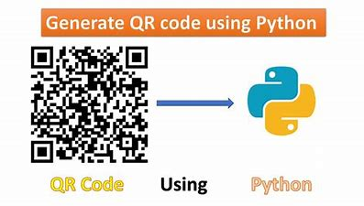

1. **Initial Step-By-Step Description:**
2. *First, you need to install*[*python3*](https://www.python.org/download/releases/3.0/)*in your system. Then, install the QR code library .Use pip3 instead of pip if you're using Linux.*
3. *We take the user input the filename and the data we need to convert into QRcode.*
4. *Using the QRcode library the data we need to convert and it will be changed into a QRcode.*
5. *The converted QR code will be saved in our local device*
6. *We can scan the QR code in our mobile to see the details hidden in the QR code.*

**Conclusion**

QR Codes and Barcodes are very common things nowadays. The real goal of a task can be easily reached by scanning it. A QR Code can contain a lot of data encoded.

In this tutorial, We have learned to make a QR Code scanner using python that can decode the encoded data from a QR Code.

Thank You,

Team Python Beginners.